Milestone 1

Computer Science 316

10/11/2018

Frank Qu, Eddie Yang, Yifan Yin

Progress Report

Our Application:

Mobile phones have become an inseparable part of our daily life, and it is better for us to choose the ones that suit our preferences best. Many cell phones nowadays are becoming more expensive, and it becomes increasingly important for us to invest in our cellphone choices.

We want to create a website that contains the database which summarizes the most important technicalities of the high-end cell phone(release date 2015 or later and MSRP $500 or above). We believe that this website can help the users to find their beloved cell phones.

Plan for getting the data to populate your database:

Our sources of data are online websites. These websites include cell phone companies’ official websites, retailer websites and cell phone rating websites. We will choose desirable attributes and select data for these attributes from online websites.

A list of assumptions:

1. We assume the names of mobile phones to be the primary key for the entity, Phone.
2. We assume the company name to be the primary key for the entity, Company.
3. We assume that attributes of phones to be null for certain tuples; for example, some phones may not have front-end cameras, so for that phone, its front camera attribute is null. Certain phones may not be rated, so their ratings are null.

The E/R diagram for our database design:

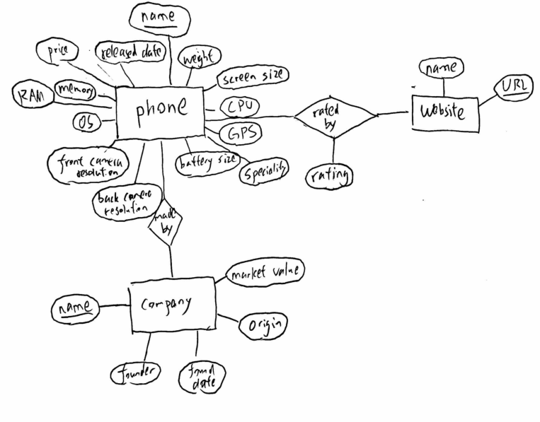

The list of database tables with keys declared:

phone(name, price, released_date, weight, screen_size, CPU, GPS, battery_size, front_camera_resolution, back_camera_resolution, OS, RAM, memory, specialty)

company(name, market_value, origin, found date, founder)

ratingwebsite(URL, name)

madeby(phone_name, company_name)

ratedby(phone_name, websiteURL, rating)

Web interface:

We want to design a website where users can select the phones that they are interested in based on brand, price range, camera resolution and other possible attributes, the website should allow comparison between different phones’ data, and sort the phones for desirable attributes(biggest RAM, biggest screen size…etc) if needed.